Sinespace GIFF

Quick Guide

Requirements

Minimum Requirements
The minimum requirements for sinespace are fairly low, however some regions and locations may require more modern hardware.

Operating System: Windows XP SP2+ or newer1, macOS 10.92 or newer, Ubuntu 12.04+ (other distributions have reported to work or SteamOS.
Graphics Card: DirectX 9 capable GPU (Supports Shader Model 3.0 or higher)
Memory: 2GB or more.
CPU: Supports SSE2 Instructions.

Recommended Requirements
The optimal experience will be seen by people with the following computer specifications

Operating System: Windows 7 or newer, macOS 10.12 or newer, Ubuntu 12.04+ (other distributions have reported to work) or SteamOS
Graphics Card: nVidia GeForce 760 or ATI Radeon R9 280X
Memory: 4GB or more
CPU: Quad-core i5 Intel CPU

Installation
We recommend you take at least 1 hour to setup the virtual world before the event.
1.- Go to
Windows 6.62 MB
https://sine.space/download/get_latest/Win64Installer
Mac 5.31 MB
https://sine.space/download/get_latest/Mac
2.- First time users, will require extra time to download worlds, following visits will
Average 160 Mb for each world

Create Account and Avatar
Use your email to create a new account
Pick a base avatar
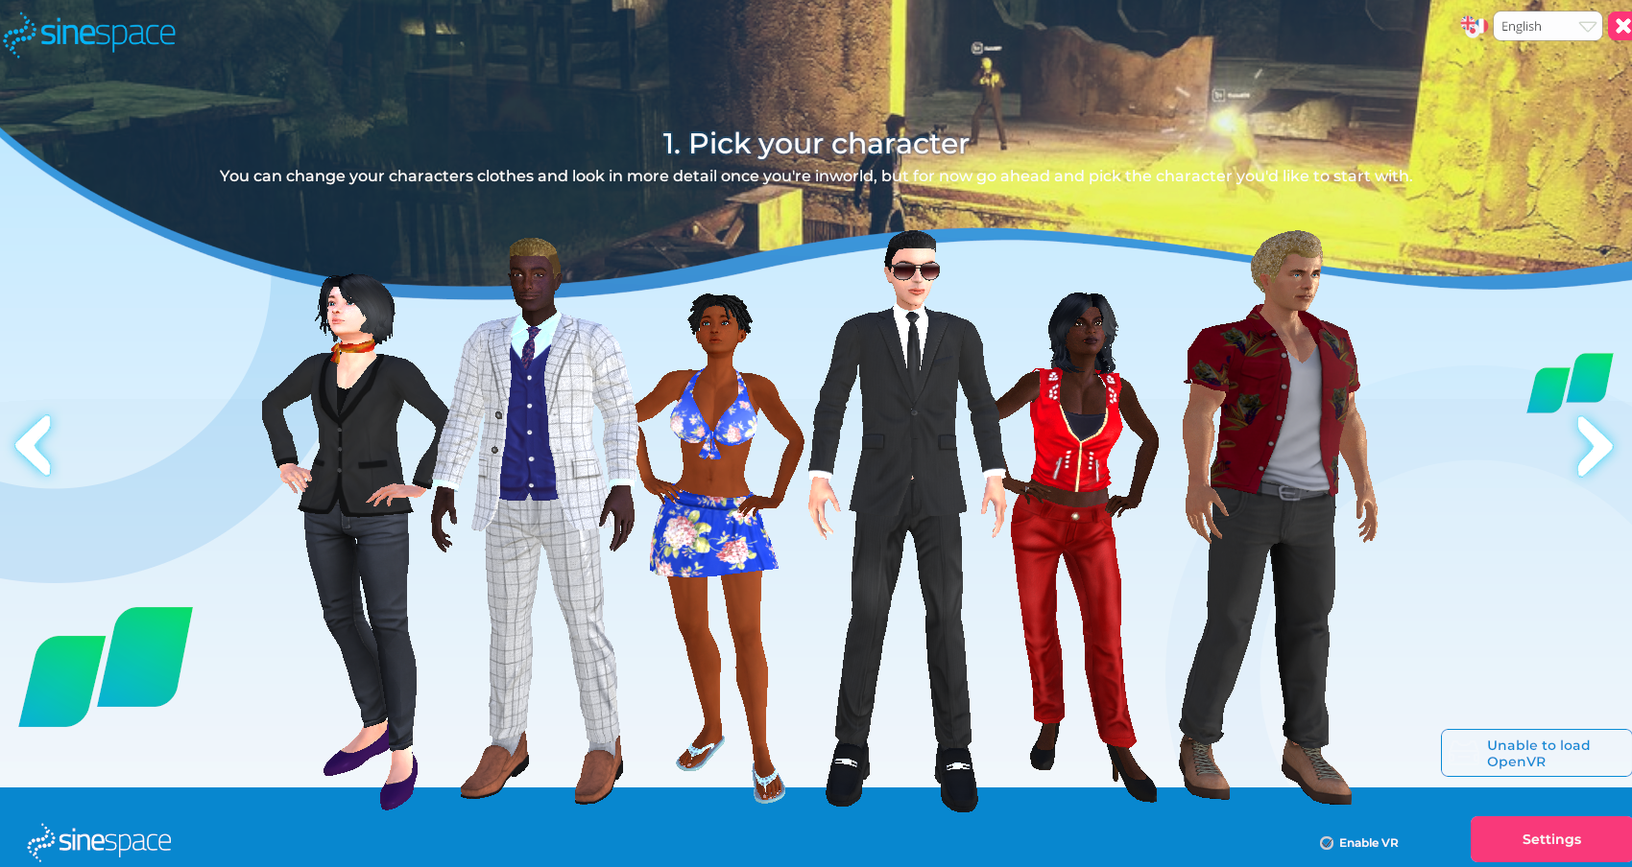
Fill form
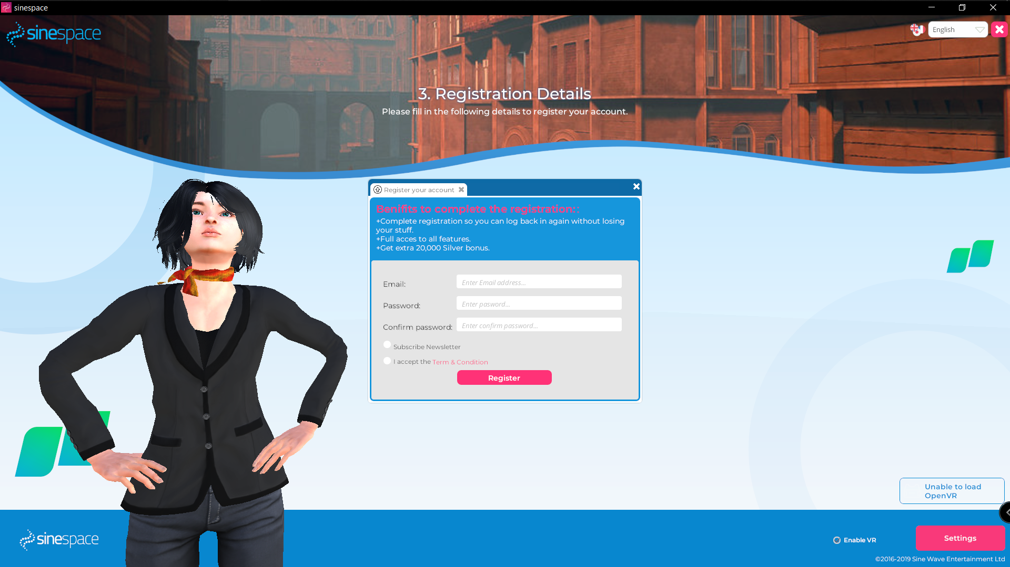

Tools

Check events and activities
Access multiple worlds with different activities each
Add and find your friends
Access your customized world
Access your clothes, furniture, gestures and regions
Change your outfit with your inventory items
Expand your inventory
Take a selfie
Activate your microphone
Help
Change Settings
Graphic Settings
Choose the configuration of graphics depending on your computer details
Audio and video settings
Choose your default microphone, speakers and camera.
VR Settings
Connect your VR headset for an immersive experience!

Keyboard

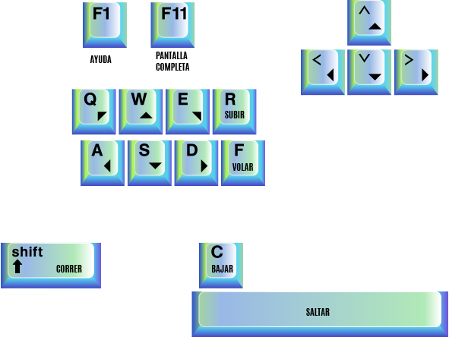

Left button >> Move to desired location
Scroll >> Zoom In – Zoom Out
Right Button >> Free camera

